 | 18 Editors - Graph Editor
Table of content
Graph Editor 2
Time cursor 2
F-Curves 2
Keyframes 2
Handles 3
Markers 3
Viewport Navigation 3
Viewport navigation 3
F-Curve Context Menu 4
Copy 4
Paste 4
Paste Flipped 4
Last operator Paste Keyframes / Flipped 4
Offset 4
Type 4
Flipped 4
Handle Type 5
Last Operator Set Keyframe Handle Type 5
Type 5
Interpolation Mode 5
Last Operator Set Keyframe Interpolation 5
Type 5
Easing Mode 5
Last Operator Set Keyframe Easing Type 5
Type 5
Insert Keyframes 5
Duplicate 6
Last Operator Duplicate 6
Mode 6
Values X / Y 6
Axis 6
Orientation 6
Proportional editing 6
Proportional Falloff 6
Proportional Size 6
Connected 6
Projected(2D) 6
Delete Keyframes 6
Mirror 6
Last Operator Mirror Keys 7
Type 7
Snap 7
Last Operator Snap Keys 7
Type 7
Slider snapping 7
Quick Favorites menu 7

Graph Editor

The Graph Editor allows you to adjust animation curves for your animations. So called Function curves. In short F-Curves

The Graph editor has several areas.
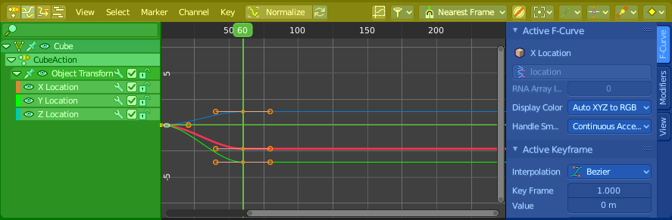
Header ( Yellow )
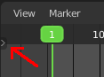
Channel list ( Green ).
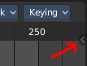
Sidebar ( Blue ).
Viewport ( no color )
The header is divided into two parts. Left tools and menus. Right Options. And in the middle the playback elements for the animation.
Menus ( Green )
Options ( Yellow )

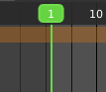
Time cursor
The Time Cursor is the green line. It is used to set and display the current time frame.

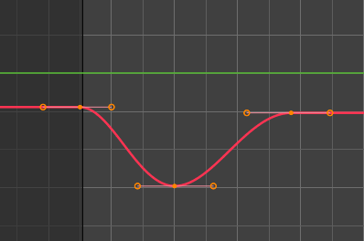
F-Curves
The timeline displays the function curves for the animation. This curve can also be manipulated in various ways.

Keyframes
In the Graph editor every keyframe is represented by a dot and the handlers for it.

Handles
Every keyframe has handles assigned. The curve can be manipulated by dragging these handlers. You can also change the handle type in the Keyframe Handle Type menu in the header. To make the curve sharp at this keyframe for example.

Markers
Markers are visible hints to denote frames with key points or significant events within an animation. A marker could mark a character’s animation starts, the position change of a camera, or a door that opens.
Markers can be added, deleted and renamed from the Marker menu. Once created they reside at the bottom of the viewport.
To select a marker click at it.
To move a marker click and drag.
The active marker is highlighted, and shows a dotted line upwards.
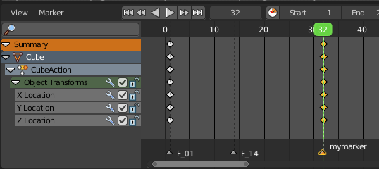

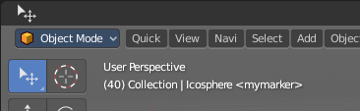
When a frame matches the marker position then the info string in the 3D view shows the name of this marker too.

Viewport Navigation

Navigation in the viewport happens by mouse or hotkeys. Some of them does not have a menu entry. And needs to be explained here.

Viewport navigation
Right mouse button moves the frame marker.
Clicking left at the number bar moves the frame marker.
Middle mouse button pans the view.
Holding ctrl + middle mouse button zooms the view.
Scroll Wheel zooms the view.
To drag a keyframe click at it and drag the mouse.
To manipulate a keyframe, grab one of its handlers and drag.

F-Curve Context Menu
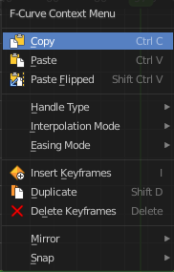
When you double right click into the viewport then you will call the F-Curve context menu.

Copy
Copies the currently selected keyframe(s).

Paste
Pastes copied keyframe(s)

Paste Flipped
Pastes copied keyframe(s), but flipped.

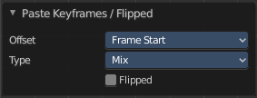
Last operator Paste Keyframes / Flipped

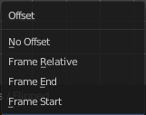
Offset
Define a time offset to paste the keys.

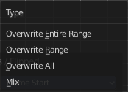
Type
The paste method.

Flipped
Paste copied curve point(s) flipped.

Handle Type
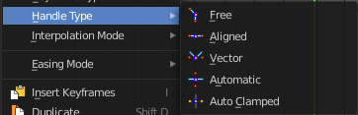
Set the handle type for the currently selected keyframes.
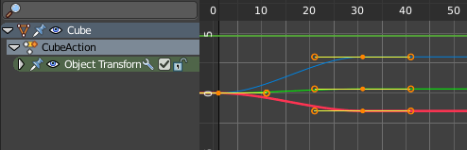
This is a feature for the Graph editor, where each curve point has its own handler with which you can influence the curve behavior. But the handler type also influences how the animation curve acts at the chosen keyframes. So it has its use in the dope sheet editor too.

Last Operator Set Keyframe Handle Type

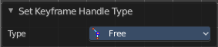
Type
Set the handle type for the currently selected curve point.

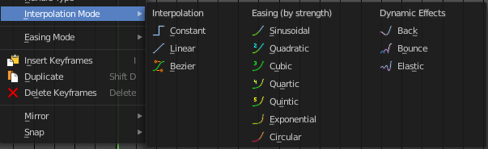
Interpolation Mode
The Interpolation mode defines how the curve acts from keyframe to keyframe. You can have a linear curve between two keyframes instead of a bent one for example.
The easing methods here in the interpolation mode menu are for the easing shape. There is also an easing menu where you can choose a easing method.

Last Operator Set Keyframe Interpolation

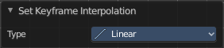
Type
Set the interpolation mode.

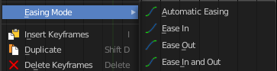
Easing Mode
The easing methods in the interpolation mode menu are for the easing shape. This menu allows you to choose an easing method.

Last Operator Set Keyframe Easing Type

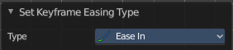
Type
Set the easing type.

Insert Keyframes
Insert a keyframe at the current position.

Duplicate
Duplicate the selected keyframe(s).

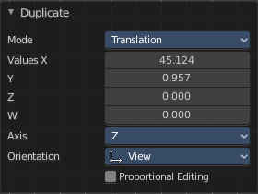
Last Operator Duplicate

Mode

Values X / Y
The x and y values for the pasted keyframes. Note that these values starts at the position of the original copied keyframe. These values are relative.
Values Z and W have no effect here.

Axis
These values have no effect.

Orientation
These values have no effect.

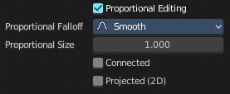
Proportional editing
Enables proportional editing. Activating proportional editing reveals further settings.

Proportional Falloff
Adjust the falloff methods.

Proportional Size
See and adjust the falloff radius.

Connected
The proportional falloff gets calculated for connected parts only.

Projected(2D)
The proportional falloff gets calculated in the screen space. Depth doesn't play a role. When it's in the radius, then it gets calculated.

Delete Keyframes
Delete the selected keyframe(s).

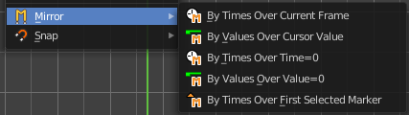
Mirror
Mirrors the animation by the given method.

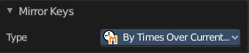
Last Operator Mirror Keys

Type
Flips the selected keyframes over the current frame position by the chosen method.

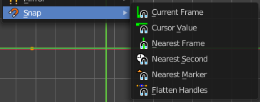
Snap
Snaps the selected keyframes by the given method.

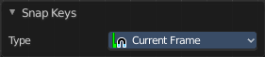
Last Operator Snap Keys

Type
Snaps the selected keyframes by the chosen method.

Slider snapping
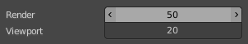
Snapping also works at sliders. Hover with the mouse over the slider, start to slide, and holding down Ctrl will snap the sliders in incremental steps.
When it's a default value between 0 and 1 then it usually snaps in 0.1 steps. When it's a default value over 1 then it usually snaps in steps of 10.
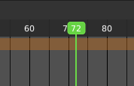
The increment snapping also works at the frame slider. Here the incremental snapping happens by the frame rate that you have defined. With a frame rate of 24 it will snap in steps of 24 frames when holding down ctrl.

Quick Favorites menu


When you right click at a menu or a button, then a right click menu will open. Tools have usually a Add to Quick Favorites menu entry.

The Quick Menu is empty by default. With Add to Quick favorites you can add this menu to the Quick menu.

In the 3D view we have a menu called Quick in the header, which shows this content then. In the Dope Sheet Editor you can just call it with its hotkey. Q. It has no regular menu entry here.

